**About Project**

* **Project Name** – CRYPTSYSTEM
* **Short Description** – It is a website which allows users to encrypt and decrypt their images and text using various algorithms.
* **Programming Language –** Html,css,js,java,Python.
* **Features -**

Image Encryption

Image Decryption

Text Encryption

Text Decryption

**Project User Interface**

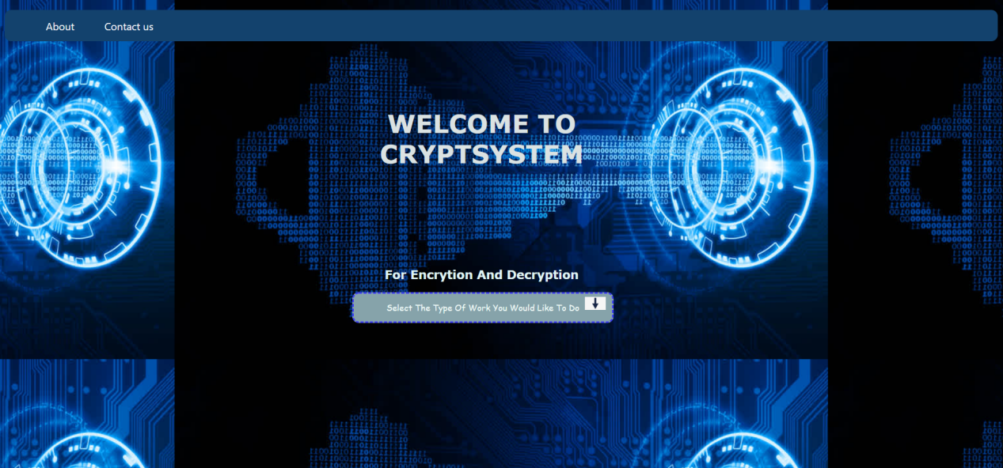

This is the interface which a user will be able to see when he will open our website.

When he/she will click drop down menu he will be able to see various options like- **Image encryption image Decryption,Text encryption and text Decryption**.

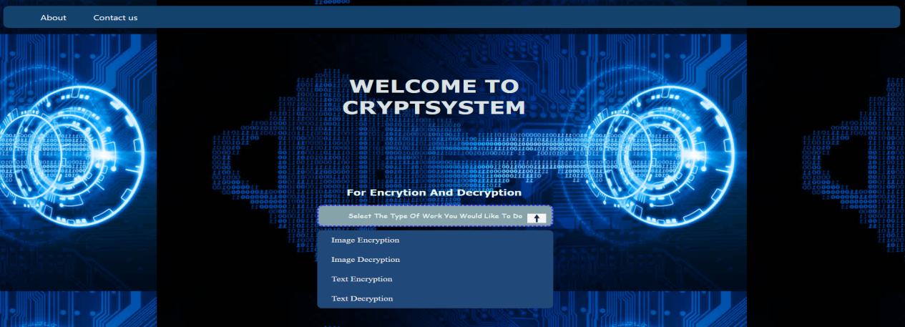

**Index**

**1 – Technical Details**

1.1 Technology and Algorithms used

1.2 Process model

1.3 Software/Hardware Requirements

1.4 Use cases

**2 – Coding Part**

**3 – Working**

**4 - future scopes**

**5 - references**

1.Technical Details

For this project I have used languages like Html,css,js.

**Reasons for selecting Html:-**

HTML allows users to create and structure sections, headings, links, paragraphs, and more, on a website using various tags and elements. Almost everything you want to create on a web page can be done using a specific HTML code.

And for this project many div’s,toggle menu’s,paragraphs and headings were needed because of which html was most suitable,

**Reasons for selecting CSS:-**

[CSS](https://www.w3.org/Style/CSS/) is the language for describing the presentation of Web pages, including colors, layout, and fonts. It allows one to adapt the presentation to different types of devices, such as large screens, small screens, or printers. CSS is independent of HTML and can be used with any XML-based markup language.

So to add styling to our website and make it beautiful css was needed.

**Reasons for selecting Js:-**

JavaScript is a text-based programming language used both on the client-side and server-side that allows you to make web pages interactive. Where HTML and CSS are languages that give structure and style to web pages, JavaScript gives web pages interactive elements that engage a user.

So to get the output after selecting text encryption and decryption js was needed.

**Reasons for selecting Python-**

Python is a high-level, interpreted, and general-purpose dynamic programming language that focuses on code readability. It generally has small programs when compared to Java and C. It was founded in 1991 by developer Guido Van Rossum. Python ranks among the most popular and fastest-growing languages in the world. Python is a powerful, flexible, and easy-to-use language. In addition, the python community is very active. It is used in many organizations as it supports multiple programming paradigms. It also performs automatic memory management.

**Reasons for selecting Java**

Java is a [high-level](https://en.wikipedia.org/wiki/High-level_programming_language" \o "High-level programming language), [class-based](https://en.wikipedia.org/wiki/Class-based_programming" \o "Class-based programming), [object-oriented](https://en.wikipedia.org/wiki/Object-oriented_programming" \o "Object-oriented programming) [programming language](https://en.wikipedia.org/wiki/Programming_language" \o "Programming language) that is designed to have as few implementation [dependencies](https://en.wikipedia.org/wiki/Dependency_(computer_science)" \o "Dependency (computer science)) as possible. It is a [general-purpose](https://en.wikipedia.org/wiki/General-purpose_language" \o "General-purpose language) programming language intended to let [programmers](https://en.wikipedia.org/wiki/Programmer" \o "Programmer) write once, run anywhere ([WORA](https://en.wikipedia.org/wiki/Write_once,_run_anywhere" \o "Write once, run anywhere)), meaning that [compiled](https://en.wikipedia.org/wiki/Compiler" \o "Compiler) Java code can run on all platforms that support Java without the need to recompile. Java applications are typically compiled to [bytecode](https://en.wikipedia.org/wiki/Java_bytecode" \o "Java bytecode) that can run on any [Java virtual machine](https://en.wikipedia.org/wiki/Java_virtual_machine" \o "Java virtual machine) (JVM) regardless of the underlying [computer architecture](https://en.wikipedia.org/wiki/Computer_architecture" \o "Computer architecture). The [syntax](https://en.wikipedia.org/wiki/Syntax_(programming_languages)" \o "Syntax (programming languages)) of Java is similar to [C](https://en.wikipedia.org/wiki/C_(programming_language)" \o "C (programming language)) and [C++](https://en.wikipedia.org/wiki/C++" \o "C++), but has fewer [low-level](https://en.wikipedia.org/wiki/Low-level_programming_language" \o "Low-level programming language) facilities than either of them.

**Below are the different features which can performed by using this minor project:**

1. Image Encryption using various algorithms like:-

Image Encryption Technique Based On combination of block Displacement and block Cipher.

Image Encryption based on the RGB PIXEL Transposition and Shuffling

Enhanced Colour Visual Cryptography

Image Encryption Based on Explosive Inter-pixel Displacement of the RGB Attributes of a Pixel

Permutation based Image Encryption Technique

Image Encryption Using Block-Based Transformation Algorithm

1. Image decryption

3 Text Encryption

1. Text Decryption

**Work/Tasks Done :-**

1. created frontend of MAIN UI page index.html where user can select various options for image encryption and decryption
2. Created frontend of About us and contact page(about.html , contact.html) where user can see what this website is about and whom to contact in case of any query.
3. Created frontend page of image encryption where user can select various options for encrypting the image(imageencoptions.html)
4. Created frontend of image decryption(imagedec.html)
5. Created fronted page of text encryption(textenc.html) where user can enter plain text and key to get the respected cipher text.
6. Created backend of text encryption (encryptiontext.js)where it will encrypt the plain text using AES
7. Created fronted page of text decryption(textdec.html) where user can enter cipher text and key to get the respected Plain text.
8. Created backend of text decryption (decryptiontext.js)where it will decrypt the cipher text using AES
9. Added styling to all the pages using CSS.
10. Image Permutation and encryption.
11. Developed code to perform Image Encryption via combination of Block Cipher and Block Displacement.
12. Developed an code to perform Image Encryption via Visual Colour Cryptography.

**1.1 Algorithm used in Text Encryption and Decryption:-**

# Advanced Encryption Standard (AES)

[Advanced Encryption Standard (AES)](https://www.geeksforgeeks.org/aes-full-form/) is a specification for the encryption of electronic data established by the U.S National Institute of Standards and Technology (NIST) in 2001. AES is widely used today as it is a much stronger than DES and triple DES despite being harder to implement.

Points to remember

* AES is a block cipher.
* The key size can be 128/192/256 bits.
* Encrypts data in blocks of 128 bits each.

That means it takes 128 bits as input and outputs 128 bits of encrypted cipher text as output. AES relies on substitution-permutation network principle which means it is performed using a series of linked operations which involves replacing and shuffling of the input data.

**Working of the cipher :**  
AES performs operations on bytes of data rather than in bits. Since the block size is 128 bits, the cipher processes 128 bits (or 16 bytes) of the input data at a time.

The number of rounds depends on the key length as follows :

* 128 bit key – 10 rounds
* 192 bit key – 12 rounds
* 256 bit key – 14 rounds

**Creation of Round keys :**  
A Key Schedule algorithm is used to calculate all the round keys from the key. So the initial key is used to create many different round keys which will be used in the corresponding round of the encryption.

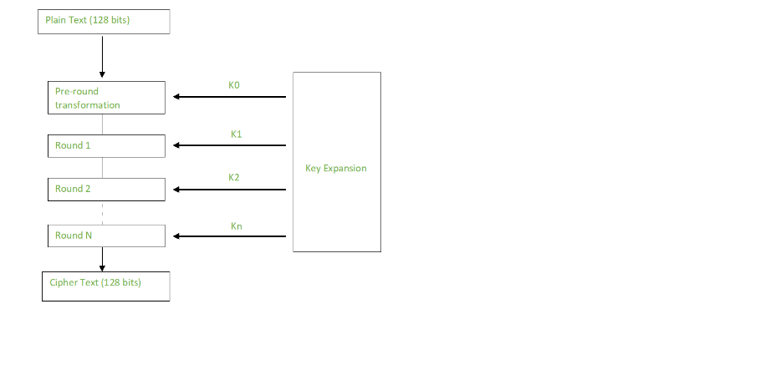

**Encryption :**  
AES considers each block as a 16 byte (4 byte x 4 byte = 128 ) grid in a column major arrangement.

**[ b0 | b4 | b8 | b12 || b1 | b5 | b9 | b13 || b2 | b6 | b10| b14 || b3 | b7 | b11| b15 ]**

Each round comprises of 4 steps :

* SubBytes
* ShiftRows
* MixColumns
* Add Round Key

The last round doesn’t have the MixColumns round.

The SubBytes does the substitution and ShiftRows and MixColumns performs the permutation in the algorithm.

**SubBytes  :**  
This step implements the substitution.

In this step each byte is substituted by another byte. Its performed using a lookup table also called the S-box. This substitution is done in a way that a byte is never substituted by itself and also not substituted by another byte which is a compliment of the current byte. The result of this step is a 16 byte (4 x 4 ) matrix like before.

The next two steps implement the permutation.

**ShiftRows :**  
This step is just as it sounds. Each row is shifted a particular number of times.

* The first row is not shifted
* The second row is shifted once to the left.
* The third row is shifted twice to the left.
* The fourth row is shifted thrice to the left.

(A left circular shift is performed.)

**[ b0 | b1 | b2 | b3 ] [ b0 | b1 | b2 | b3 ]| b4 | b5 | b6 | b7 | -> | b5 | b6 | b7 | b4 || b8 | b9 | b10 | b11 | | b10 | b11 | b8 | b9 |[ b12 | b13 | b14 | b15 ] [ b15 | b12 | b13 | b14 ]**

**MixColumns :**  
This step is basically a matrix multiplication. Each column is multiplied with a specific matrix and thus the position of each byte in the column is changed as a result.

**This step is skipped in the last round.**

**[ c0 ] [ 2 3 1 1 ] [ b0 ]| c1 | = | 1 2 3 1 | | b1 || c2 | | 1 1 2 3 | | b2 |[ c3 ] [ 3 1 1 2 ] [ b3 ]**

**Add Round Keys :**  
Now the resultant output of the previous stage is XOR-ed with the corresponding round key. Here, the 16 bytes is not considered as a grid but just as 128 bits of data.

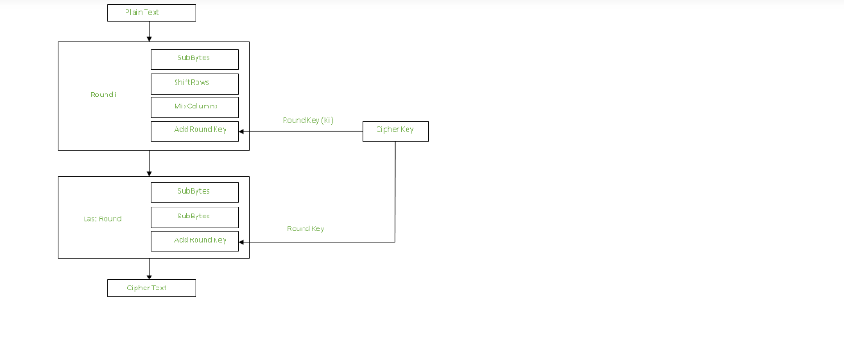

After all these rounds 128 bits of encrypted data is given back as output. This process is repeated until all the data to be encrypted undergoes this process.

**Decryption :**  
The stages in the rounds can be easily undone as these stages have an opposite to it which when performed reverts the changes.Each 128 blocks goes through the 10,12 or 14 rounds depending on the key size.

The stages of each round in decryption is as follows :

* Add round key
* Inverse MixColumns
* ShiftRows
* Inverse SubByte

The decryption process is the encryption process done in reverse so i will explain the steps with notable differences.

**Inverse MixColumns :**  
 This step is similar to the MixColumns step in encryption, but differs in the matrix used to carry out the operation.

**[ b0 ] [ 14 11 13 9 ] [ c0 ]| b1 | = | 9 14 11 13 | | c1 || b2 | | 13 9 14 11 | | c2 |[ b3 ] [ 11 13 9 14 ] [ c3 ]**

**Inverse SubBytes :**  
Inverse S-box is used as a lookup table and using which the bytes are substituted during decryption.

**Summary :**  
AES instruction set is now integrated into the CPU (offers throughput of several GB/s)to improve the speed and security of applications that use AES for encryption and decryption. Even though its been 20 years since its introduction we have failed to break the AES algorithm as it is infeasible even with the current technology. Till date the only vulnerability remains in the implementation of the algorithm.

**1.2 Process model used**

For this model we have used RAD Model because for this project we have to develop functionalities of image and text encryption and decryption where more functionalities can be added after completing 1 cycle.

# Rapid application development model (RAD)

The Rapid Application Development Model was first proposed by IBM in the 1980s. The critical feature of this model is the use of powerful development tools and techniques. A software project can be implemented using this model if the project can be broken down into small modules wherein each module can be assigned independently to separate teams. These modules can finally be combined to form the final product. Development of each module involves the various basic steps as in the waterfall model i.e analyzing, designing, coding, and then testing, etc. as shown in the figure. Another striking feature of this model is a short time span i.e the time frame for delivery(time-box) is generally 60-90 days.

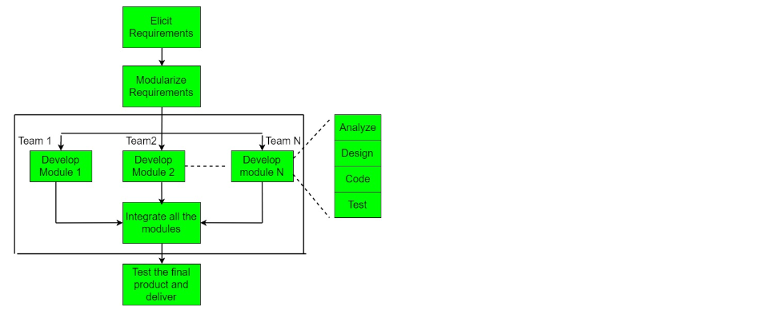

### Advantages:

* The use of reusable components helps to reduce the cycle time of the project.
* Feedback from the customer is available at the initial stages.
* Reduced costs as fewer developers are required.
* The use of powerful development tools results in better quality products in comparatively shorter time spans.
* The progress and development of the project can be measured through the various stages.
* It is easier to accommodate changing requirements due to the short iteration time spans.

**1.3 Software/Hardware Requirements**

To run this website user’s need laptop of any os Like:-

* Windows/Linux/Mac

And to view the coding part users need an IDE like visual studio code which can open any language code like html,css and js.

**1.4 Use Cases:-**

* :As a chief security officer I want to send encrypted messages to my team members so that an intruder can’t read them in between.
* :As a school teacher I want to send encrypted questions to hod for exam so that no intruder can decrypt it.
* :As an employee I want to share confidential messages with my colleagues in encrypted manner so that no one can decrypt them.
* : As a student / teacher / employee, I want to send image to my colleagues in encrypted form.
  1. **Algorithm used in Image Encryption and Decryption:-**

**Visual Colour Cryptography**

**Inrodution**

Visual cryptography scheme (VCS) is a kind of secret-sharing scheme which allows the encryption of a secret image into n shares that are distributed to n participants. The beauty of such a scheme is that, the decryption of the secret image requires neither the knowledge of cryptography nor complex computation. Colour visual cryptography becomes an interesting research topic after the formal introduction of visual cryptography by Naor and Shamir in 1995. The authors propose a colour (k, n)-VCS under the visual cryptography model of Naor and Shamir with no pixel expansion, and a colour (k, n)-extended visual cryptography scheme ((k, n)-EVCS) under the visual cryptography model of Naor and Shamir with pixel expansion the same as that of its corresponding black and white (k, n)-EVCS. Furthermore, the authors propose a black and white (k, n)-VCS and a black and white (k, n)-EVCS under the visual cryptography model of Tuyls. Based on the black and white schemes, the authors propose a colour (k, n)-VCS and a colour (k, n)-EVCS under the same visual cryptography model, of which the pixel expansions are the same as that of their corresponding black and white (k, n)-VCS and (k, n)-EVCS, respectively. The authors also give the experimental results of the proposed schemes, and compare the proposed scheme with known schemes in the literature.

**Visual Colour Cryptography Basic Model**

In Visual cryptography, a secret binary image is programmed into n shares of arbitrary binary prototypes. It is possible to decode the secret image visually by superimposing a qualified subset of transparencies. Nevertheless no secret data can be acquired from the superposition of an illegal subset [12, 13, 14]. Visual cryptography is a type of cryptography in which image can be securely encrypted by dividing them in a distorted image called transparent shares and transmitted through physically by printing these shares an transparency sheets to the intended user. Visual cryptography assumes in many forms such as for grayscale images, black and white images as well as color images. In the Grayscale model, to ensure the transparencies the white pixels of blackand-white images as transparent. Typically, the black-andwhite visual cryptography decomposes every pixel in a secret image into a 2x2 black in the two transparencies according to the rules of the basic model. When a pixel is white, the method chooses one of the two combinations of white pixels to form the content of the block in the two transparencies. When a pixel is black, it chooses one of the other two combinations. Then, the characteristics of resulting pixel for two stacked pixels are as follows; black, if both are black white, if both are white black otherwise.

**Major Steps**

* Consider the input secret image as the RGB model color image. •
* The input image is now fed to the error diffusion process that uses Floyd – Steinberg
* algorithm to diffuse the image. •
* Repeat Step-2 until every pixel in the image is decomposed. The dithering process then computes the standard sixteen named color codes. •
* According to the traditional method of Naor and Shamir’s black and white VC Schemes, expand each pixel into 2 X 2 blocks arrays. •
* This step results in generation of two shares (transparencies) of the secret image. • Finally, the stacked image is produced by combining the two shares that are generated.

**Steps in the algorithm** •

* Input the input secret image as the RGB model color image •
* Input to the original image. •
* Create the key value having 32 to 448 bits. •
* Encrypt the image using Blowfish algorithm. •
* Decrypt the encrypted image using the same key •
* End.

1. **Coding**

**Algorithms for image encryption:-**

**Algorithm 1 : Image Encryption using combination of Block Cipher and Block Displacement.**

**Libararies Used :**

* Java.io
* Java.security
* Java.swing
* Java.crypto

**Future Scopes :**

* Block ciphers function similarly to keystream ciphers but have different properties. Block ciphers are useful for data-at-rest encrypted storage, but they can also be used to implement a keystream-like bit-by-bit encrypted communications mechanism.
* Block ciphers must be designed such that knowledge of large amounts of matched input and output blocks is insufficient to determine the key other than by [exhaustive search](https://www.sciencedirect.com/topics/engineering/exhaustive-search" \o "Learn more about exhaustive search from ScienceDirect's AI-generated Topic Pages) of all possible keys for the applicable key length.

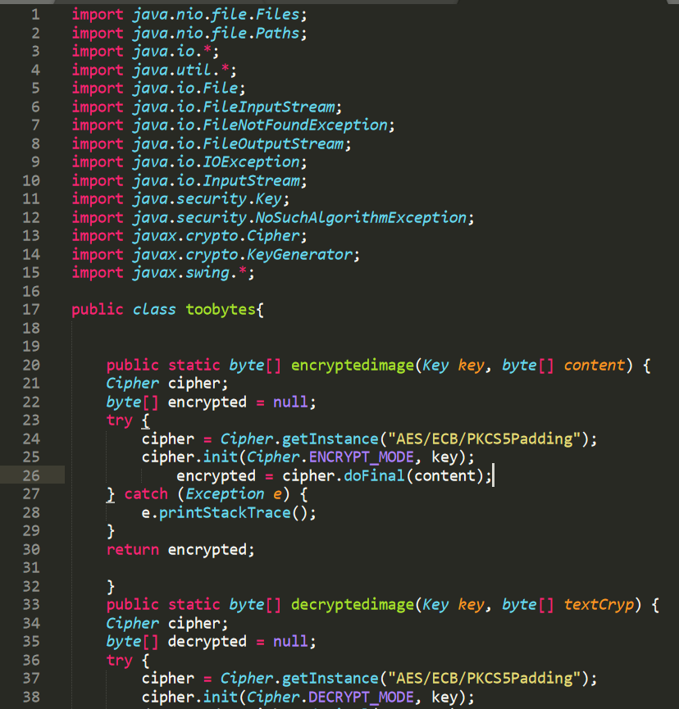

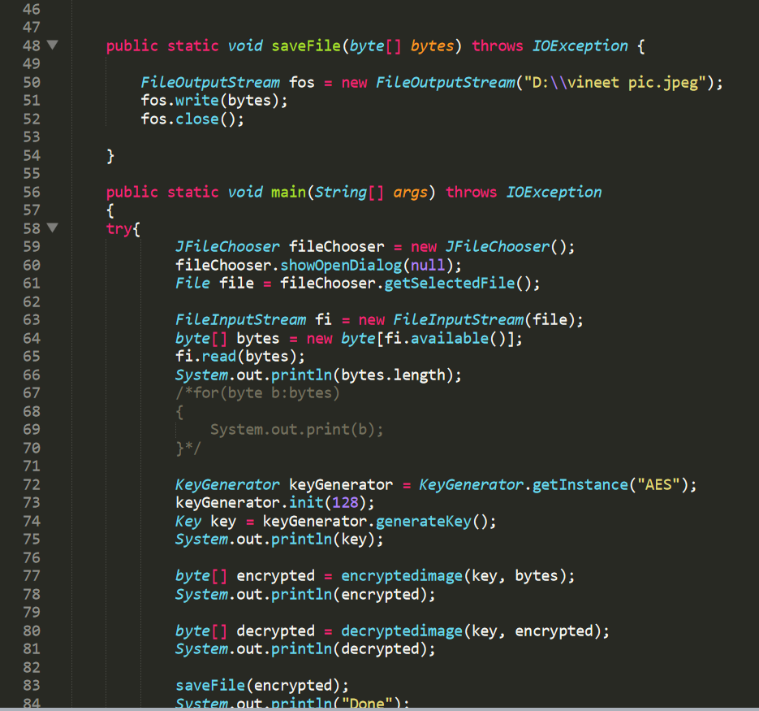

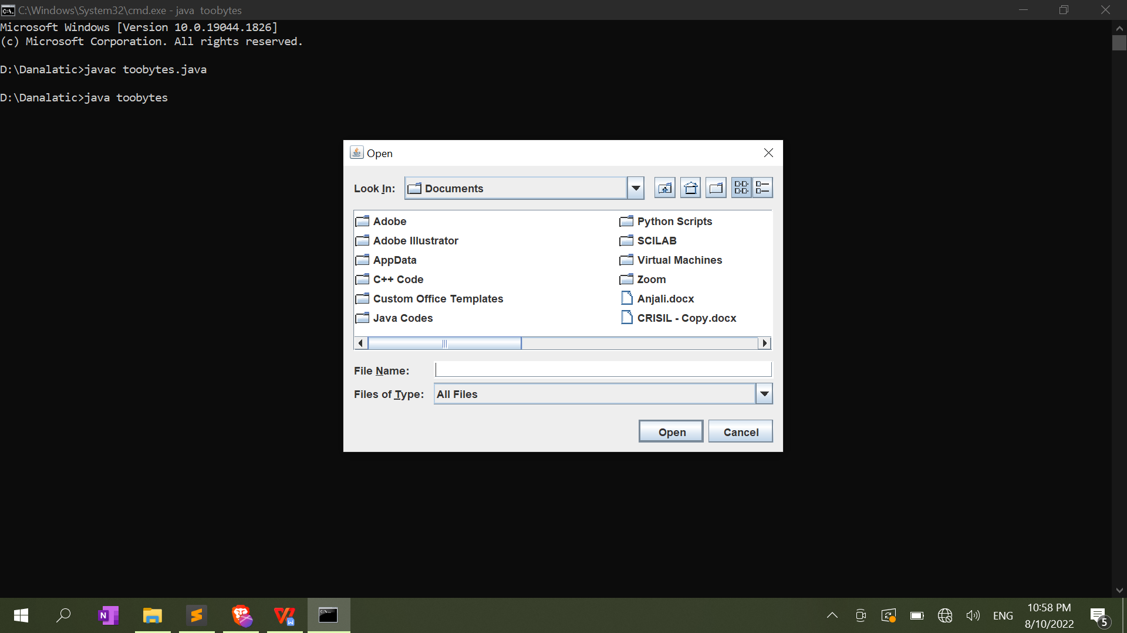

**Algorithm 2: Image Encryption using Colour Visual Cryptography**

**Libraries Used :**

* Java.awt
* Java.swing
* Java.util
* Java.text

**Future Scopes :**

The future work will cover the Multi level visual secret sharing technique, howthe pixel expansion rate will be reduced and in what way high quality targetimage will be obtained which indeed increases the storage requirements for sheets and the target image

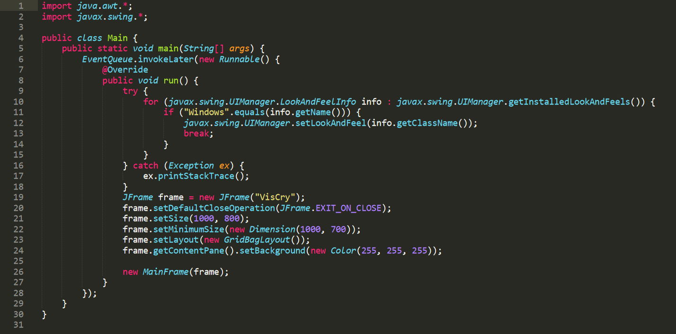

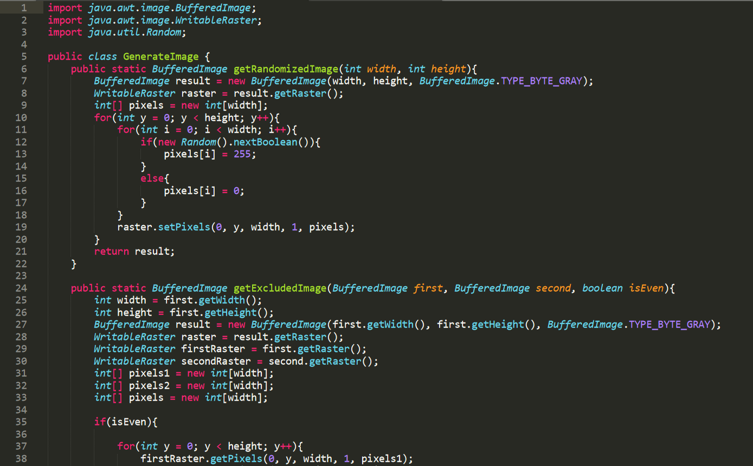

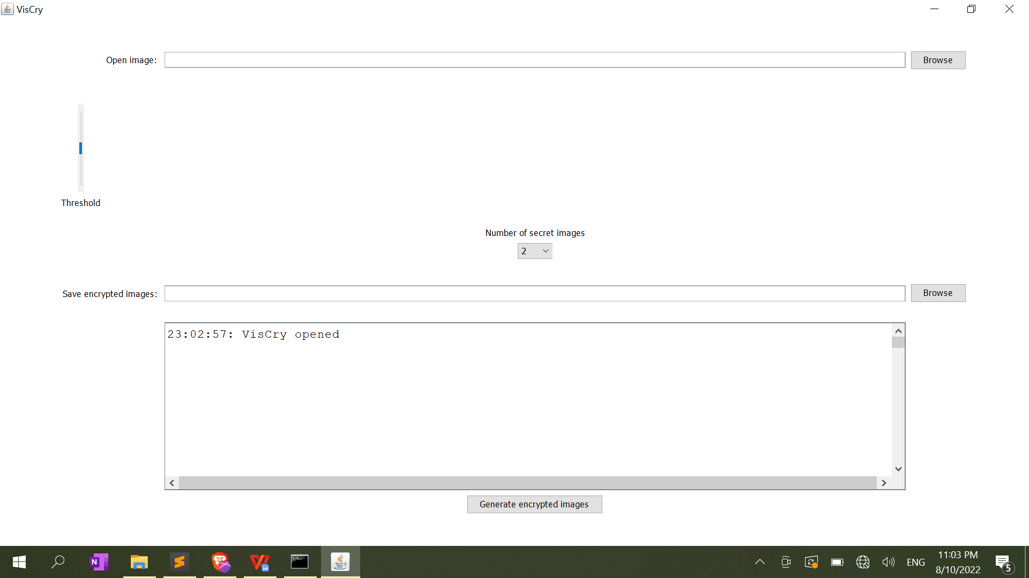

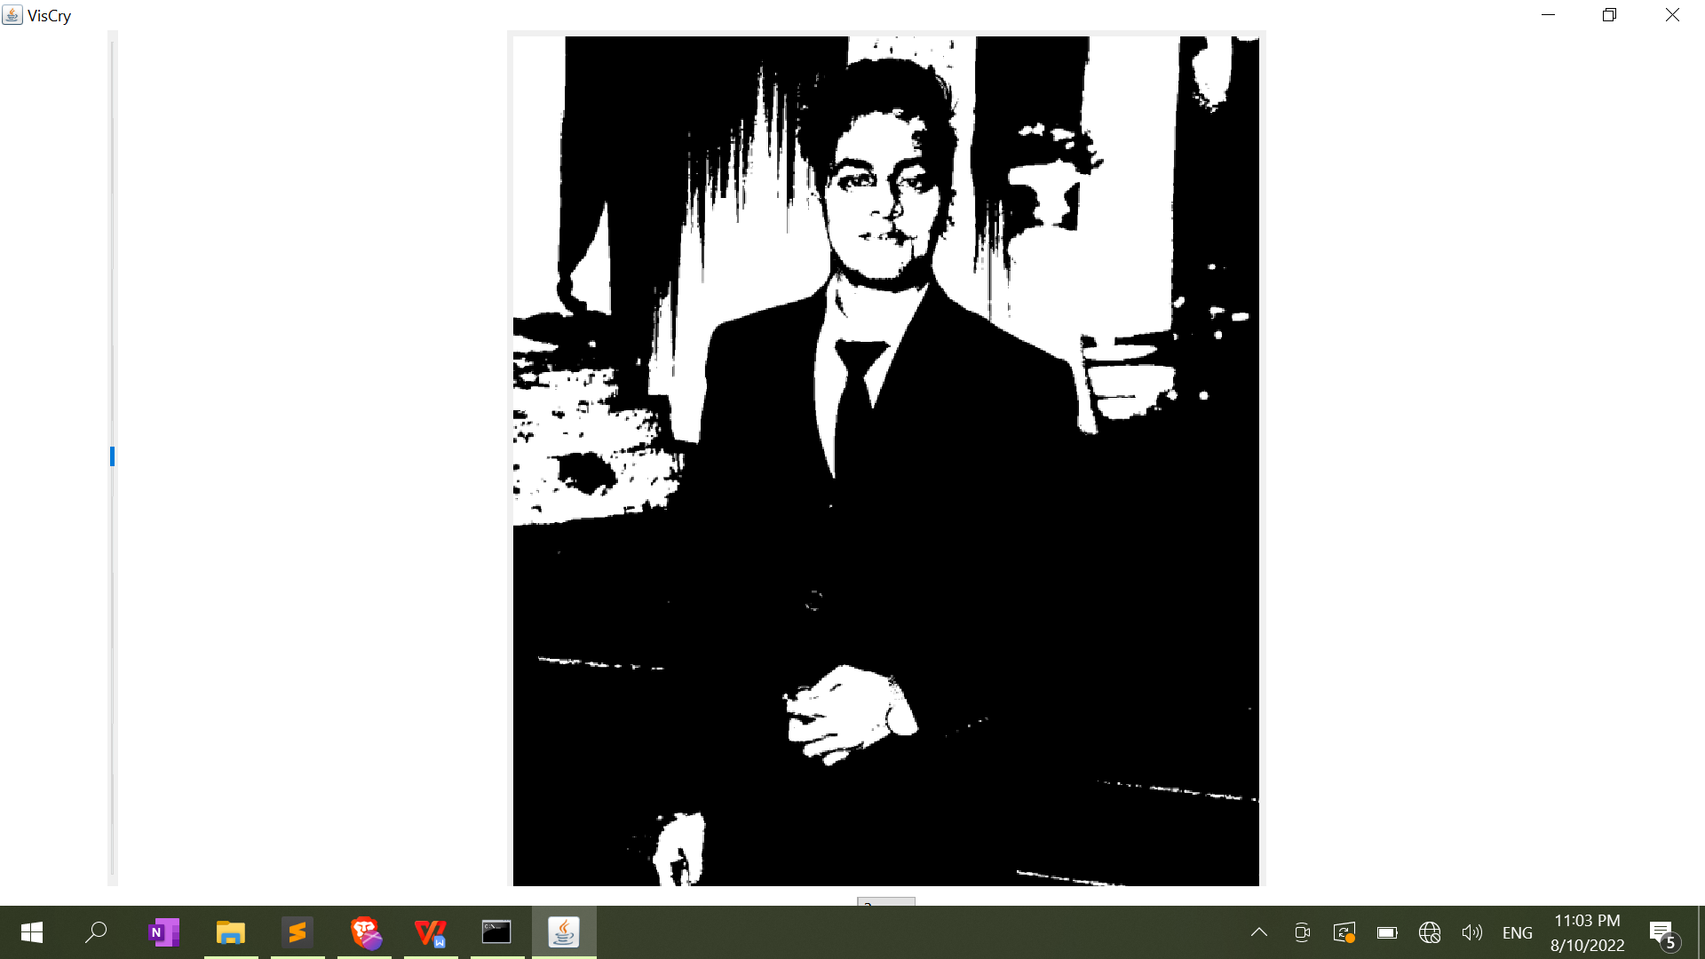

**This is the coding part of frontends.**

Index.html

<!DOCTYPE html>

<html lang="en">

  <head>

    <meta charset="UTF-8" />

    <meta http-equiv="X-UA-Compatible" content="IE=edge" />

    <meta name="viewport" content="width=device-width, initial-scale=1.0" />

    <title>cryptsystem</title>

    <link rel="stylesheet" href="style.css" />

  </head>

  <body>

    <header>

      <nav class="navbar">

        <ul>

          <li><a href="about.html">About </a></li>

          <li><a href="contact.html">Contact us </a></li>

        </ul>

      </nav>

    </header>

    <main>

      <div class="class1">

        <h1>Welcome to CryptSystem</h1>

      </div>

      <div class="container">

        <h2>For encrytion and decryption</h2>

        <div class="selectbox">

          <div class="optionscontainer">

            <div class="option" onclick="window.location='imgencoptions.html'">

              <input

                type="radio"

                class="radio"

                id="iencryption"

                name="category"

              />

              <label for="iencryption">Image Encryption</label>

            </div>

            <div class="option" onclick="window.location='imagedec.html'">

              <input

                type="radio"

                class="radio"

                id="idecryption"

                name="category"

              />

              <label for="idecryption">Image Decryption</label>

            </div>

            <div class="option" onclick="window.location='textenc.html'">

              <input

                type="radio"

                class="radio"

                id="tencryption"

                name="category"

              />

              <label for="tencryption">Text Encryption</label>

            </div>

            <div class="option" onclick="window.location='textdec.html'">

              <input

                type="radio"

                class="radio"

                id="tdecryption"

                name="category"

              />

              <label for="tdecryption">Text Decryption</label>

            </div>

          </div>

          <div class="selected">

            select the type of work you would like to do

          </div>

        </div>

      </div>

    </main>

    <script src="main.js"></script>

  </body>

</html>

Main.js

const selected = document.querySelector(".selected");

const optionsContainer = document.querySelector(".optionscontainer");

const optionsList = document.querySelectorAll(".option");

selected.addEventListener("click", () => { optionsContainer.classList.toggle("active");

});

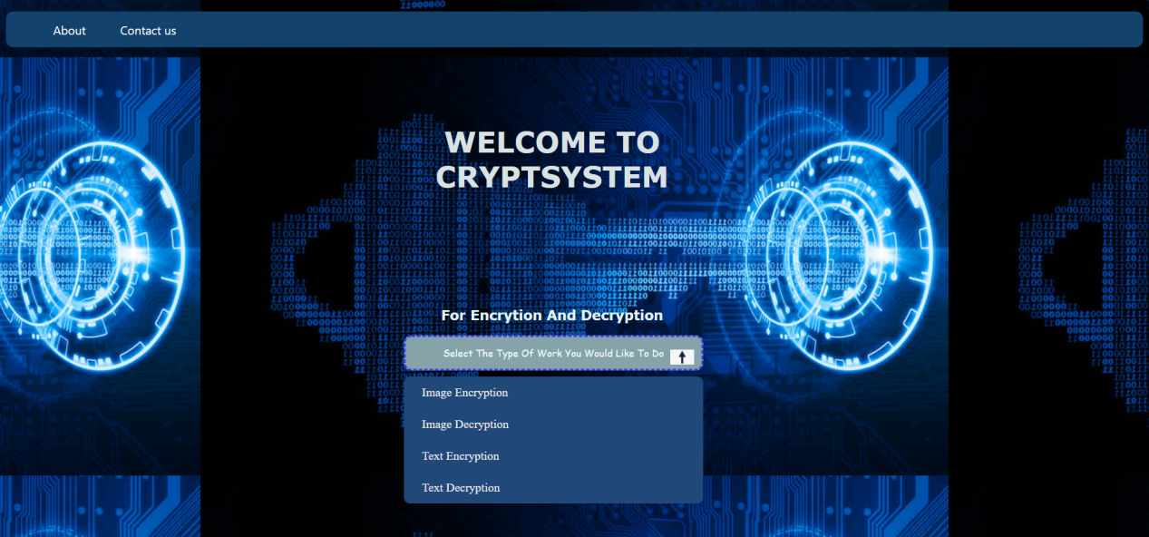

About.html

<!DOCTYPE html>

<html lang="en">

  <head>

    <meta charset="UTF-8" />

    <meta http-equiv="X-UA-Compatible" content="IE=edge" />

    <meta name="viewport" content="width=device-width, initial-scale=1.0" />

    <title>Aboutus</title>

    <link rel="stylesheet" href="style.css" />

  </head>

  <body>

    <header></header>

    <main>

      <div class="aboutdiv">

        <h1>

          This website will do encrytion and decryption of images and text

        </h1>

      </div>

      <div class="infoaes">

        <p>

          Image Encryption is done using algorithms like:-<br />

          1. Image Encryption Technique Based On Combination of Block

          Displacement and Block Cipher Technique <br />2. Image Encryption

          based on the RGB PIXEL Transposition and Shuffling <br />3. Enhanced

          Colour Visual Cryptography <br />4. Image Encryption Based on

          Explosive Inter-pixel Displacement of the RGB Attributes of a Pixel

          <br />5. Permutation based Image Encryption Technique <br />6. Image

          Encryption Using Block-Based Transformation Algorithm <br />And it

          will do Text encryption and decryption using AES algorithm. Advanced

          Encryption Standard (AES) is a specification for the encryption of

          electronic data established by the U.S National Institute of Standards

          and Technology (NIST) in 2001. AES is widely used today as it is a

          much stronger than DES and triple DES despite being harder to

          implement.

          <br />

          <a

            href="https://www.geeksforgeeks.org/advanced-encryption-standard-aes/"

            target="_blank"

            >To read more about it click here</a

          >

          <br />

        </p>

      </div>

    </main>

  </body>

</html>

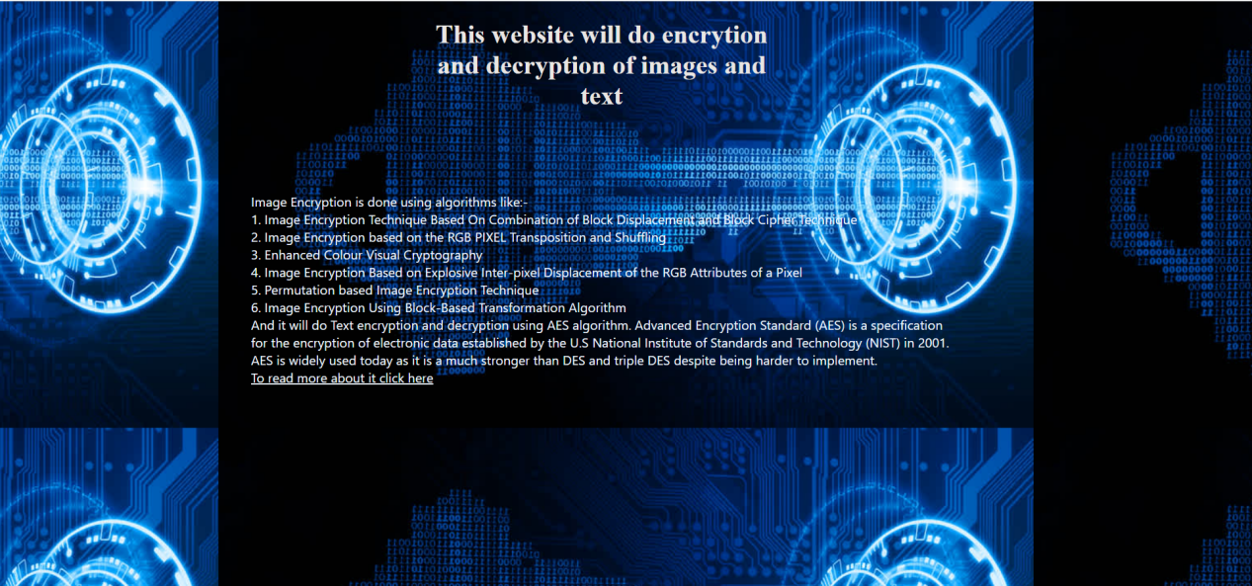

Contact.html

<!DOCTYPE html>

<html lang="en">

  <head>

    <meta charset="UTF-8" />

    <meta http-equiv="X-UA-Compatible" content="IE=edge" />

    <meta name="viewport" content="width=device-width, initial-scale=1.0" />

    <title>Contactus</title>

    <link rel="stylesheet" href="style.css" />

  </head>

  <body>

    <header></header>

    <main>

      <div class="contactdiv">

        <h1>Here you can see Contacts in case of any confusion</h1>

      </div>

      <div class="contactlist">

        <ul>

          <li><a href="#">+91-xyzjdub </a></li>

          <li><a href="#">+91-abcjsi </a></li>

        </ul>

        <!-- <br />

          <a

            href="https://www.geeksforgeeks.org/advanced-encryption-standard-aes/"

            target="_blank"

            >To read more about it click here</a

          >

          <br /> -->

      </div>

    </main>

  </body>

</html>

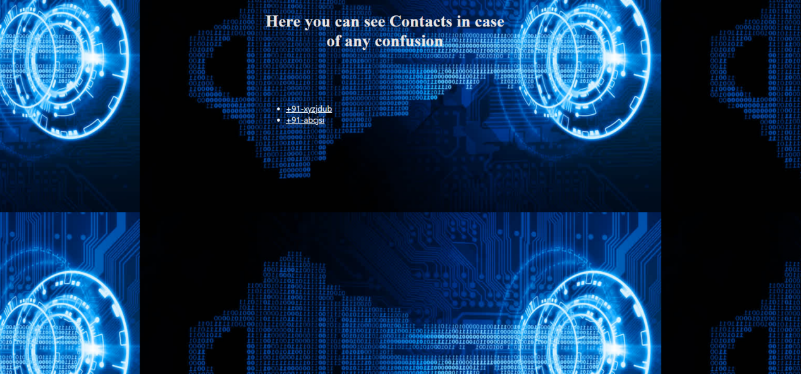

Imageencoptions.html

<!DOCTYPE html>

<html lang="en">

  <head>

    <meta charset="UTF-8" />

    <meta http-equiv="X-UA-Compatible" content="IE=edge" />

    <meta name="viewport" content="width=device-width, initial-scale=1.0" />

    <title>Imgencoptions</title>

    <link rel="stylesheet" href="style.css" />

  </head>

  <body>

    <header></header>

    <main>

      <div class="msg">

        <h1>Please select the algorithm for image encrytion</h1>

      </div>

      <select

        name="pages"

        id=""

        class="imgencdrop"

        placeholder="Select option"

        onchange="window.location.href=this.value;"

      >

        <option value="">Select option</option>

        <option value="imageenc.html">

          Block Displacement and block Cipher

        </option>

        <option value="rgbenc.html">

          RGB pixel Transportation and shuffling

        </option>

        <option value="cryptoenc.html">Color visual cryptography</option>

        <option value="pixelenc.html">

          Explosive inter pixel displacement

        </option>

        <option value="permutationenc.html">Permutation based</option>

        <option value="blockenc.html">Block based Transformation</option>

      </select>

    </main>

  </body>

</html>

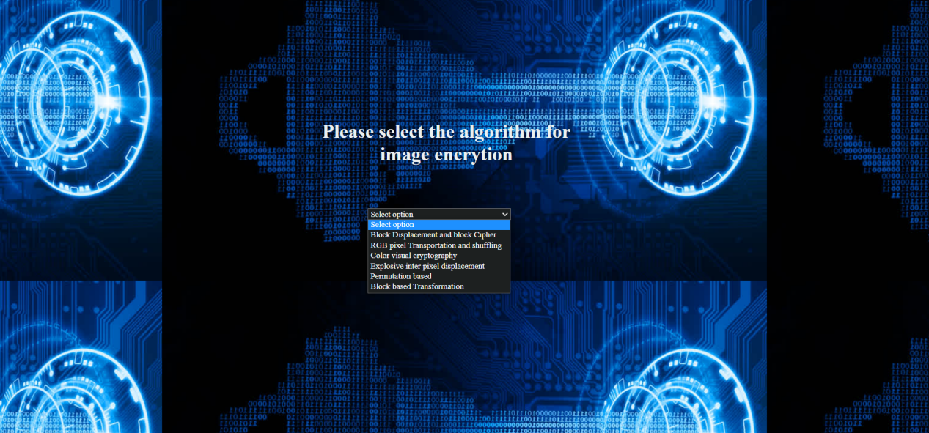

Imageenc.html

<!DOCTYPE html>

<html lang="en">

  <head>

    <meta charset="UTF-8" />

    <meta http-equiv="X-UA-Compatible" content="IE=edge" />

    <meta name="viewport" content="width=device-width, initial-scale=1.0" />

    <title>Imageencryption</title>

    <link rel="stylesheet" href="style.css" />

  </head>

  <body>

    <header></header>

    <main>

      <div class="msg">

        <h1>Please upload the image file to be encrypted</h1>

      </div>

      <input

        type="file"

        class="imgupload"

        onchange="readURL(this)"

        accept="Image/*"

      />

    </main>

  </body>

</html>

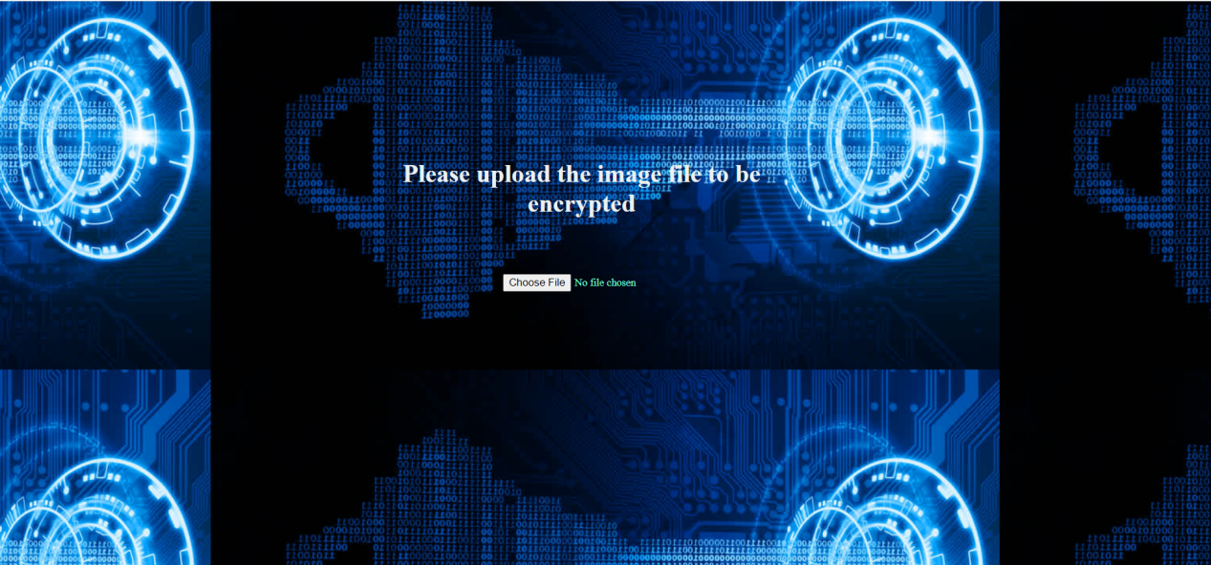

Cryptoenc.html

<!DOCTYPE html>

<html lang="en">

  <head>

    <meta charset="UTF-8" />

    <meta http-equiv="X-UA-Compatible" content="IE=edge" />

    <meta name="viewport" content="width=device-width, initial-scale=1.0" />

    <title>Cryptoimageencryption</title>

    <link rel="stylesheet" href="style.css" />

  </head>

  <body>

    <header></header>

    <main>

      <div class="msg">

        <h1>Please upload the image file to be encrypted</h1>

      </div>

      <input

        type="file"

        class="imgupload"

        onchange="readURL(this)"

        accept="Image/*"

      />

    </main>

  </body>

</html>

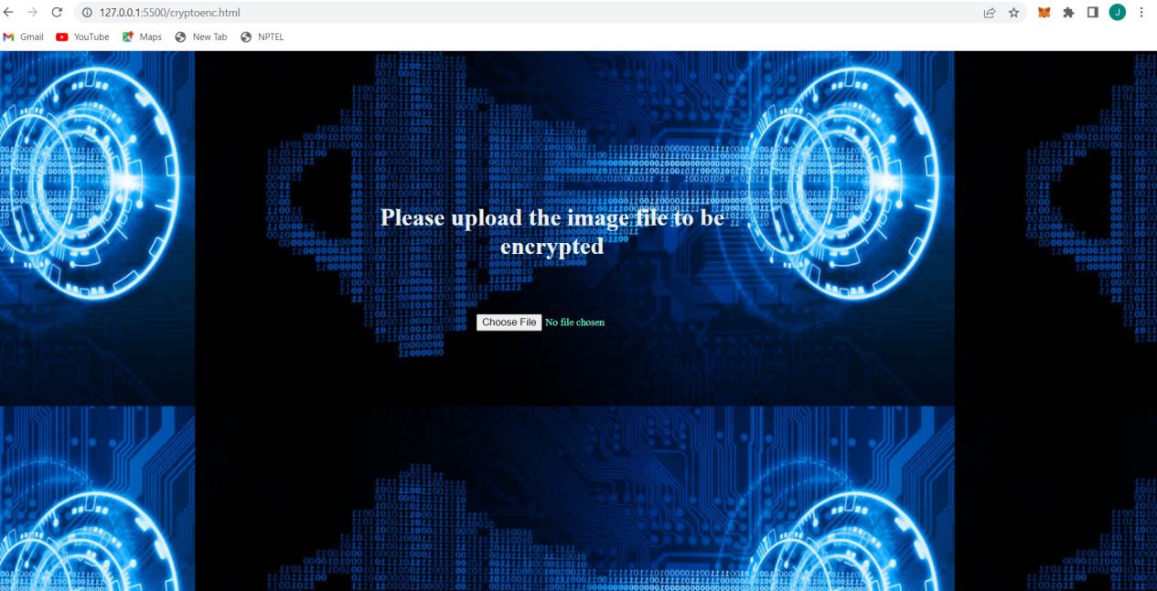

Blockenc.html

<!DOCTYPE html>

<html lang="en">

  <head>

    <meta charset="UTF-8" />

    <meta http-equiv="X-UA-Compatible" content="IE=edge" />

    <meta name="viewport" content="width=device-width, initial-scale=1.0" />

    <title>Blockimageencryption</title>

    <link rel="stylesheet" href="style.css" />

  </head>

  <body>

    <header></header>

    <main>

      <div class="msg">

        <h1>Please upload the image file to be encrypted</h1>

      </div>

      <input

        type="file"

        class="imgupload"

        onchange="readURL(this)"

        accept="Image/*"

      />

    </main>

  </body>

</html>

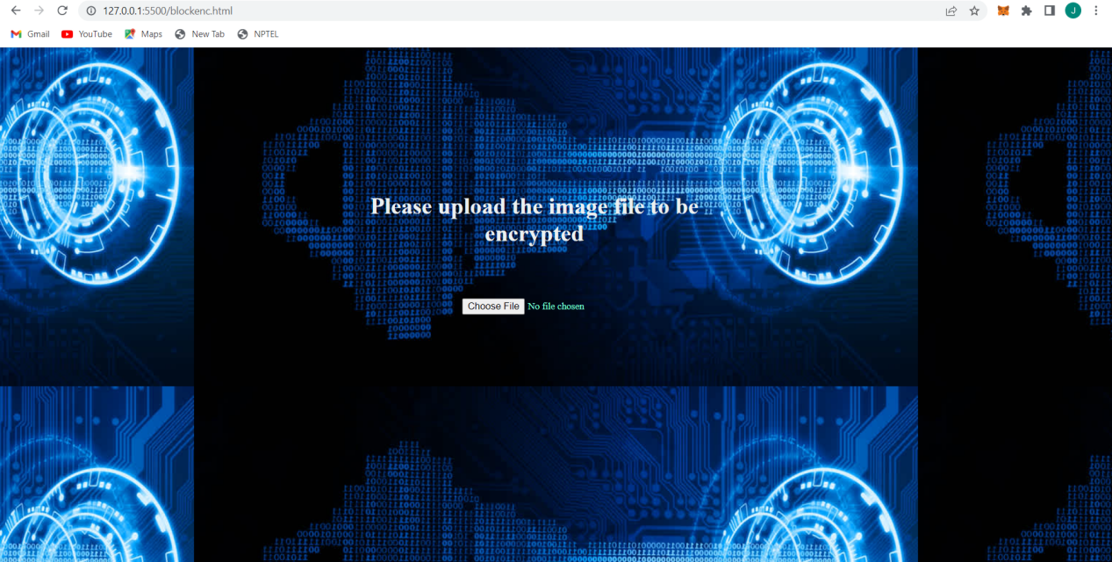

Permutationenc.html

<!DOCTYPE html>

<html lang="en">

  <head>

    <meta charset="UTF-8" />

    <meta http-equiv="X-UA-Compatible" content="IE=edge" />

    <meta name="viewport" content="width=device-width, initial-scale=1.0" />

    <title>Permutationimageencryption</title>

    <link rel="stylesheet" href="style.css" />

  </head>

  <body>

    <header></header>

    <main>

      <div class="msg">

        <h1>Please upload the image file to be encrypted</h1>

      </div>

      <input

        type="file"

        class="imgupload"

        onchange="readURL(this)"

        accept="Image/*"

      />

    </main>

  </body>

</html>

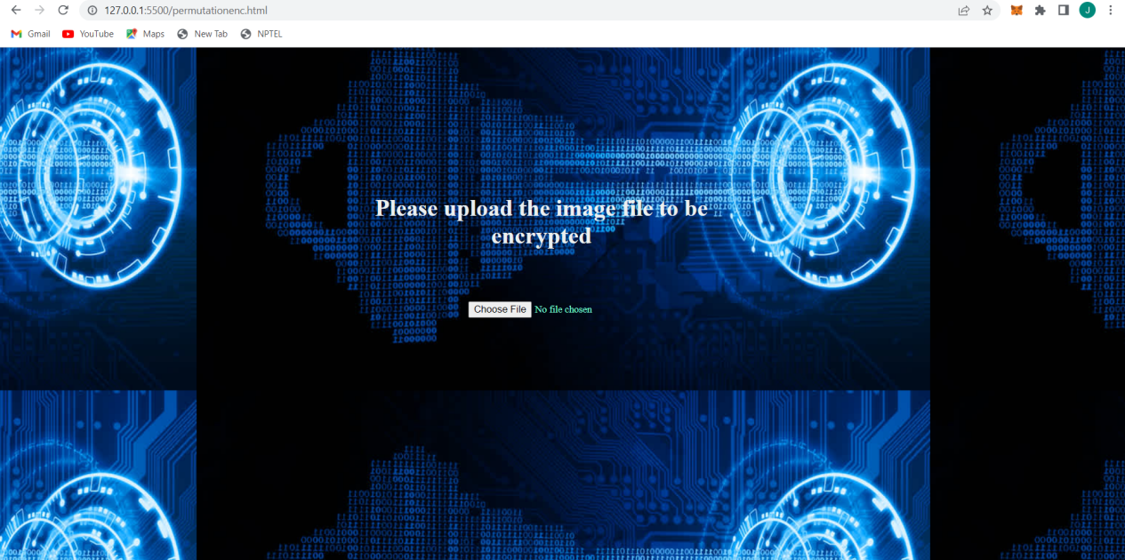

Pixelenc.html

<!DOCTYPE html>

<html lang="en">

  <head>

    <meta charset="UTF-8" />

    <meta http-equiv="X-UA-Compatible" content="IE=edge" />

    <meta name="viewport" content="width=device-width, initial-scale=1.0" />

    <title>Pixelimageencryption</title>

    <link rel="stylesheet" href="style.css" />

  </head>

  <body>

    <header></header>

    <main>

      <div class="msg">

        <h1>Please upload the image file to be encrypted</h1>

      </div>

      <input

        type="file"

        class="imgupload"

        onchange="readURL(this)"

        accept="Image/*"

      />

    </main>

  </body>

</html>

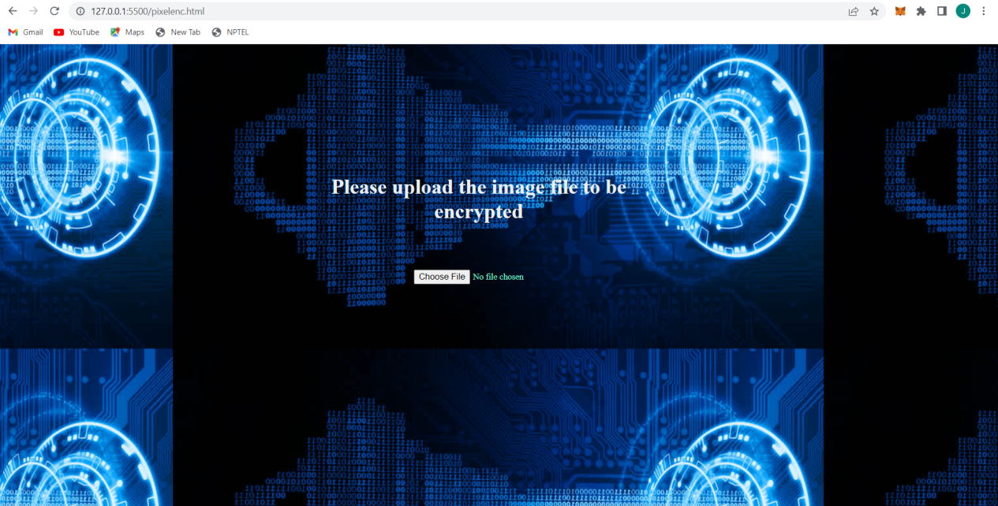

rgbenc.html

<!DOCTYPE html>

<html lang="en">

  <head>

    <meta charset="UTF-8" />

    <meta http-equiv="X-UA-Compatible" content="IE=edge" />

    <meta name="viewport" content="width=device-width, initial-scale=1.0" />

    <title>Rgbimageencryption</title>

    <link rel="stylesheet" href="style.css" />

  </head>

  <body>

    <header></header>

    <main>

      <div class="msg">

        <h1>Please upload the image file to be encrypted</h1>

      </div>

      <input

        type="file"

        class="imgupload"

        onchange="readURL(this)"

        accept="Image/*"

      />

    </main>

  </body>

</html>

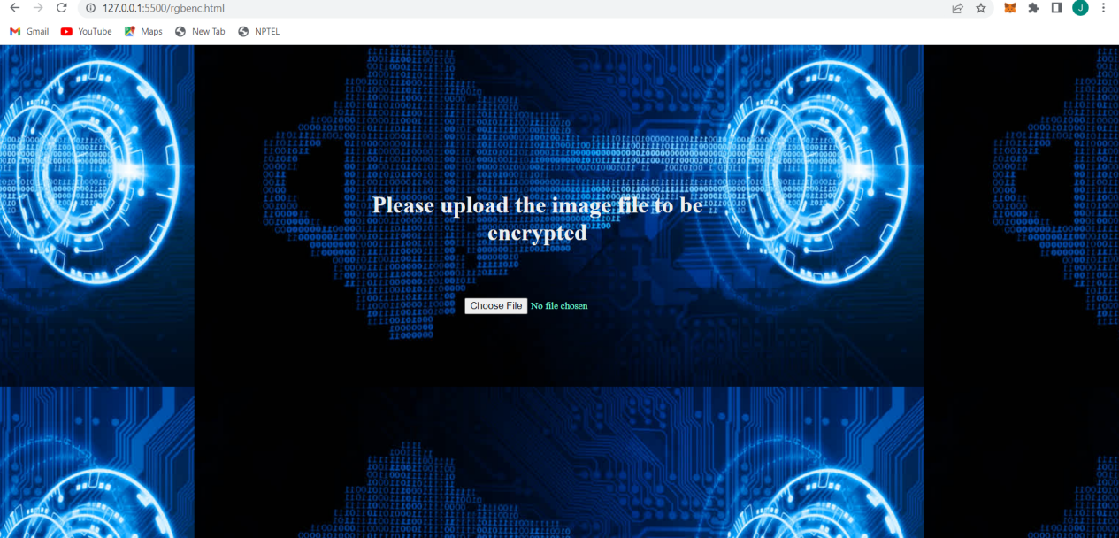

textenc.html

<!DOCTYPE html>

<html lang="en">

  <head>

    <meta charset="UTF-8" />

    <meta http-equiv="X-UA-Compatible" content="IE=edge" />

    <meta name="viewport" content="width=device-width, initial-scale=1.0" />

    <title>textencryption</title>

    <link rel="stylesheet" href="style.css" />

  </head>

  <body>

    <header></header>

    <main>

      <div class="msg">

        <h1>Enter the text to be encrypted</h1>

      </div>

      <input type="text" id="text1" placeholder="Type here" />

      <br />

      <input type="text" id="pass" placeholder="Enter key" />

      <br />

      <button onclick="fun1()" id="btn1">Submit</button>

      <br />

      <div id="resultcontainer">result:<span id="result"></span></div>

    </main>

    <script src="encryptiontext.js"></script>

    <script

      src="https://cdnjs.cloudflare.com/ajax/libs/crypto-js/4.1.1/crypto-js.min.js"

      integrity="sha512-E8QSvWZ0eCLGk4km3hxSsNmGWbLtSCSUcewDQPQWZF6pEU8GlT8a5fF32wOl1i8ftdMhssTrF/OhyGWwonTcXA=="

      crossorigin="anonymous"

      referrerpolicy="no-referrer"

    ></script>

  </body>

</html>

Imagedec.html

<!DOCTYPE html>

<html lang="en">

  <head>

    <meta charset="UTF-8" />

    <meta http-equiv="X-UA-Compatible" content="IE=edge" />

    <meta name="viewport" content="width=device-width, initial-scale=1.0" />

    <title>Imagedecryption</title>

    <link rel="stylesheet" href="style.css" />

  </head>

  <body>

    <header></header>

    <main>

      <div class="msg">

        <h1>Please upload the image file to be Decrypted</h1>

      </div>

      <input

        type="file"

        class="imgupload"

        onchange="readURL(this)"

        accept="Image/*"

      />

    </main>

  </body>

</html>

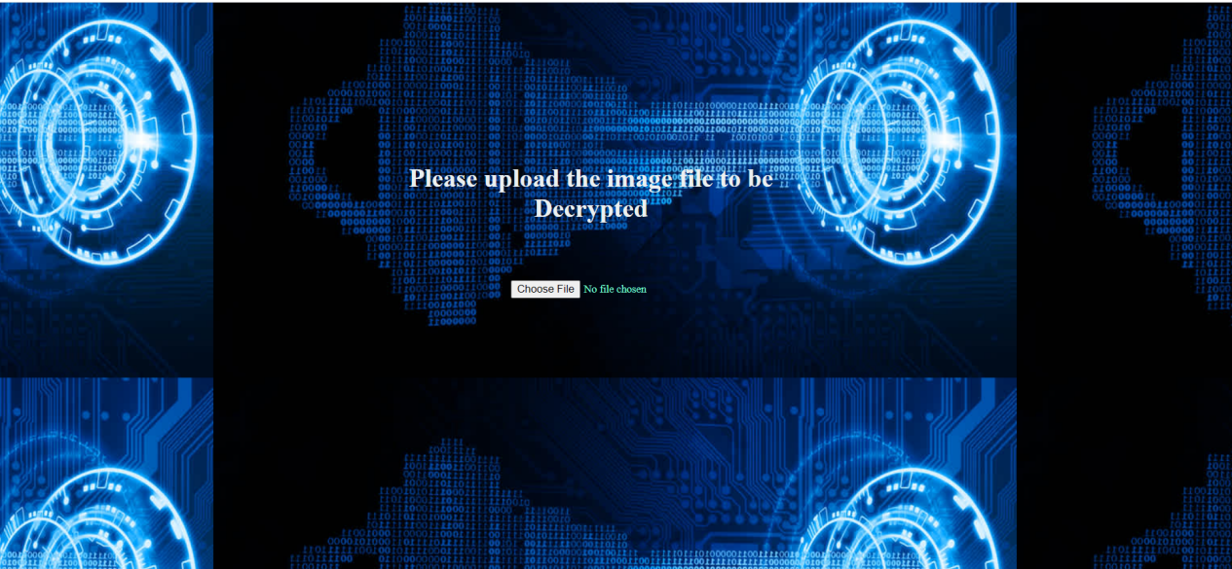

Encryptiontext.js

function fun1()

{

    console.log(document.getElementById("text1").value,document.getElementById("pass").value);

    var encrypted =CryptoJS.AES.encrypt(document.getElementById("text1").value,document.getElementById("pass").value);

    console.log(encrypted);

    document.getElementById("result").innerHTML=encrypted;

}

function fun2()

{

    var str=document.getElementById("text2").nodeValue;

    alert("the decrypted value is");

}

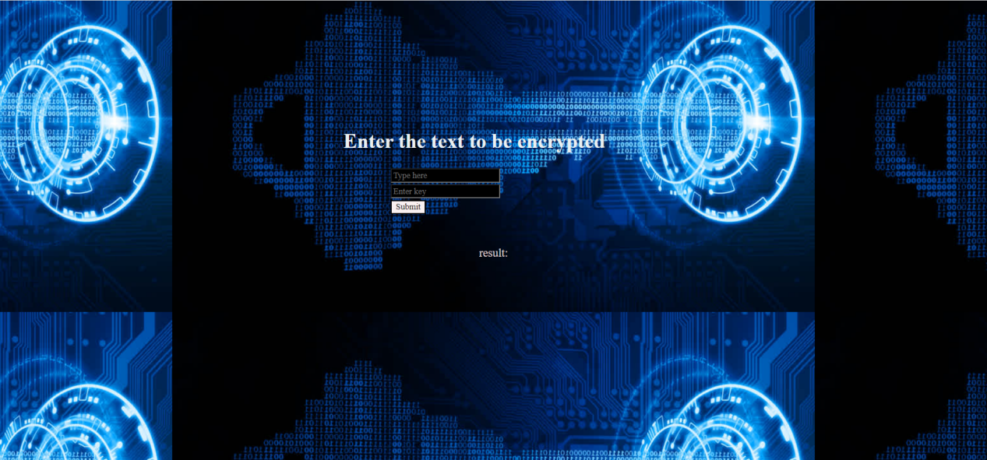

textdec.js

<!DOCTYPE html>

<html lang="en">

  <head>

    <meta charset="UTF-8" />

    <meta http-equiv="X-UA-Compatible" content="IE=edge" />

    <meta name="viewport" content="width=device-width, initial-scale=1.0" />

    <title>textdecryption</title>

    <link rel="stylesheet" href="style.css" />

  </head>

  <body>

    <header></header>

    <main>

      <div class="msg">

        <h1>Enter the text to be Decrypted</h1>

      </div>

      <input type="text" id="text2" placeholder="Type here" />

      <br />

      <input type="text" id="pass2" placeholder="Enter key" />

      <br />

      <button onclick="fun2()" id="btn1">Submit</button>

      <br />

      <div id="resultcontainer">result:<span id="result2"></span></div>

    </main>

    <script src="decryptiontext.js"></script>

    <script

      src="https://cdnjs.cloudflare.com/ajax/libs/crypto-js/4.1.1/crypto-js.min.js"

      integrity="sha512-E8QSvWZ0eCLGk4km3hxSsNmGWbLtSCSUcewDQPQWZF6pEU8GlT8a5fF32wOl1i8ftdMhssTrF/OhyGWwonTcXA=="

      crossorigin="anonymous"

      referrerpolicy="no-referrer"

    ></script>

  </body>

</html>

decryptiontext.js

function fun2()

{

    console.log(document.getElementById("text2").value,document.getElementById("pass2").value);

    var decrypted =CryptoJS.AES.decrypt(document.getElementById("text2").value,document.getElementById("pass2").value).toString(CryptoJS.enc.Utf8);

    console.log(decrypted);

    document.getElementById("result2").innerHTML=decrypted;

}

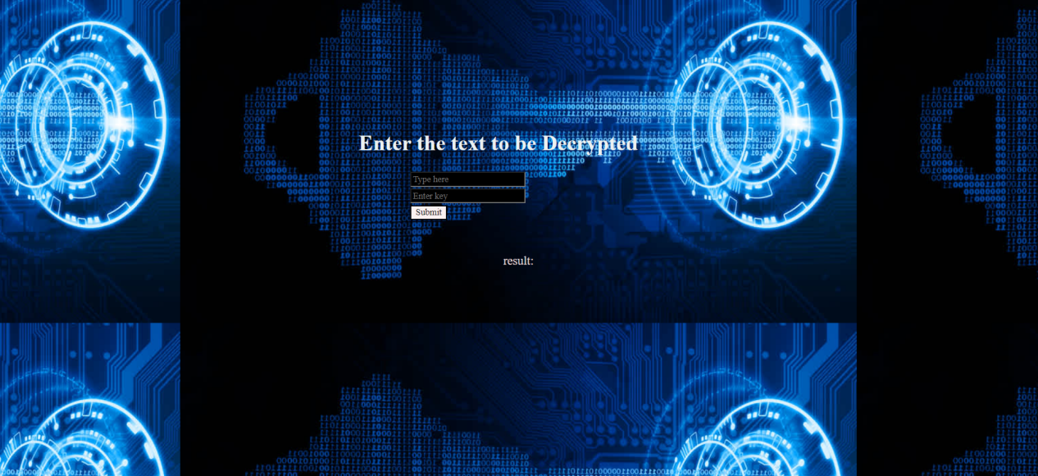

Style.css

.navbar {

  background-color: rgb(19, 66, 109);

  border-radius: 10px;

}

.navbar ul {

  overflow: auto;

}

.navbar li {

  float: left;

  list-style: none;

  margin: 13px 20px;

}

.navbar li a {

  padding: 3px 3px;

  text-decoration: none;

  color: rgb(255, 255, 255);

}

.navbar li a:hover {

  color: rgb(185, 68, 214);

}

.class1 {

  /* background-color: rgb(77, 87, 87); */

  /* border-color: darkgreen; */

  color: rgb(58, 214, 136);

  text-align: center;

  text-transform: uppercase;

  font-size: larger;

  font-family: Verdana, Geneva, Tahoma, sans-serif;

  margin-top: 100px;

  margin-right: 560px;

  margin-left: 500px;

  /* border: dashed; */

  border-color: rgb(80, 133, 64);

  border-radius: 10px;

}

.class1 h1 {

  padding: 3px 30px;

  color: rgb(219, 226, 226);

}

.aboutdiv h1 {

  text-decoration: solid;

  font-family: "Times New Roman", Times, serif;

  color: rgb(233, 230, 227);

  margin-left: 500px;

  margin-right: 560px;

  text-align: center;

}

.contactdiv h1 {

  text-decoration: solid;

  font-family: "Times New Roman", Times, serif;

  color: rgb(233, 230, 227);

  margin-left: 500px;

  margin-right: 560px;

  text-align: center;

}

.infoaes {

  color: aliceblue;

  margin-top: 100px;

  margin-left: 300px;

  margin-right: 360px;

}

.msg {

  margin-left: 500px;

  margin-right: 560px;

  margin-top: 200px;

  color: rgb(236, 240, 240);

  text-align: center;

  font-family: "Times New Roman", Times, serif;

}

#text1 {

  margin-left: 600px;

  margin-right: 560px;

  color: rgb(248, 240, 240);

  background-color: black;

  font-family: "Times New Roman", Times, serif;

}

#pass {

  margin-left: 600px;

  margin-right: 560px;

  color: rgb(248, 240, 240);

  background-color: black;

  font-family: "Times New Roman", Times, serif;

}

#pass2 {

  margin-left: 600px;

  margin-right: 560px;

  color: rgb(248, 240, 240);

  background-color: black;

  font-family: "Times New Roman", Times, serif;

}

#text2 {

  margin-left: 600px;

  margin-right: 560px;

  color: rgb(248, 240, 240);

  background-color: black;

  font-family: "Times New Roman", Times, serif;

}

#resultcontainer,

#result {

  color: rgb(228, 216, 216);

  text-align: center;

  margin-top: 50px;

  /* margin-left: 450px; */

  font-family: "Times New Roman", Times, serif;

  font-size: large;

}

#btn1 {

  margin-left: 600px;

  margin-right: 560px;

  color: rgb(29, 25, 25);

  background-color: rgb(250, 241, 241);

  font-family: "Times New Roman", Times, serif;

}

.imgupload {

  color: aquamarine;

  margin-top: 50px;

  margin-left: 630px;

  margin-right: 560px;

  font-family: "Times New Roman", Times, serif;

}

.contactlist ul {

  color: aliceblue;

  margin-top: 100px;

  margin-left: 500px;

  margin-right: 360px;

}

.contactlist a {

  color: aliceblue;

}

.contactlist a:hover {

  color: rgb(185, 68, 214);

}

.infoaes a {

  color: aliceblue;

}

.infoaes a:hover {

  color: rgb(185, 68, 214);

}

body {

  font-family: -apple-system, BlinkMacSystemFont, "Segoe UI", Roboto, Oxygen,

    Ubuntu, Cantarell, "Open Sans", "Helvetica Neue", sans-serif;

  background-image: url("img/encryption.jpg");

  /* background-repeat: no-repeat; */

  background-position: center;

  /* background-attachment: fixed; */

}

h2 {

  margin: 16px;

  color: rgb(224, 245, 245);

  text-transform: capitalize;

  text-align: center;

  font-size: large;

  font-family: Verdana, Geneva, Tahoma, sans-serif;

}

.container {

  margin-top: 100px;

  padding: 32px;

  margin-left: 500px;

  margin-right: 560px;

}

.selectbox {

  display: flex;

  width: 400px;

  flex-direction: column;

}

.selectbox .optionscontainer {

  background: #204979;

  color: rgb(235, 235, 230);

  max-height: 0;

  width: 100%;

  opacity: 0;

  transition: all 0.4s;

  border-radius: 8px;

  overflow: hidden;

  order: 1;

}

.option {

  color: rgb(241, 237, 237);

  text-align: left;

  font-family: "Times New Roman", Times, serif;

}

.selected {

  background: rgb(134, 163, 170);

  border-radius: 10px;

  margin-bottom: 8px;

  color: rgb(239, 250, 247);

  text-transform: capitalize;

  text-align: center;

  font-size: small;

  font-family: cursive;

  position: relative;

  order: 0;

  border: dashed;

  border-color: rgb(62, 62, 245);

}

.selected::after {

  content: "";

  background: url("img/1419129125.jpg");

  background-size: contain;

  background-repeat: no-repeat;

  position: absolute;

  height: 100%;

  width: 32px;

  right: 10px;

  top: 5px;

  transition: all 0.4s;

}

.selectbox .optionscontainer.active {

  max-height: 240px;

  opacity: 1;

  /* overflow-y: scroll; */

}

.selectbox .optionscontainer.active + .selected::after {

  transform: rotateX(180deg);

  top: -6px;

}

.selectbox .option,

.selected {

  padding: 12px 24px;

  cursor: pointer;

}

.selectbox .option:hover {

  background: rgb(125, 236, 171);

}

.selectbox label {

  cursor: pointer;

}

.selectbox .option .radio {

  display: none;

}

.imgencdrop {

  margin-left: 600px;

  margin-top: 50px;

  background-color: rgb(29, 32, 32);

  color: rgb(253, 250, 250);

  font-family: "Times New Roman", Times, serif;

}

**3 Working**

**Image encryption:-**







**Text encryption**

Suppose a user have entered a plain text hello and the private key as abc shared between sender and receiver he will get a corresponding cipher text for it as U2FsdGVkX18V5rnsh7MPMlN29vQZhjU/Ke/h6ePBWlI=

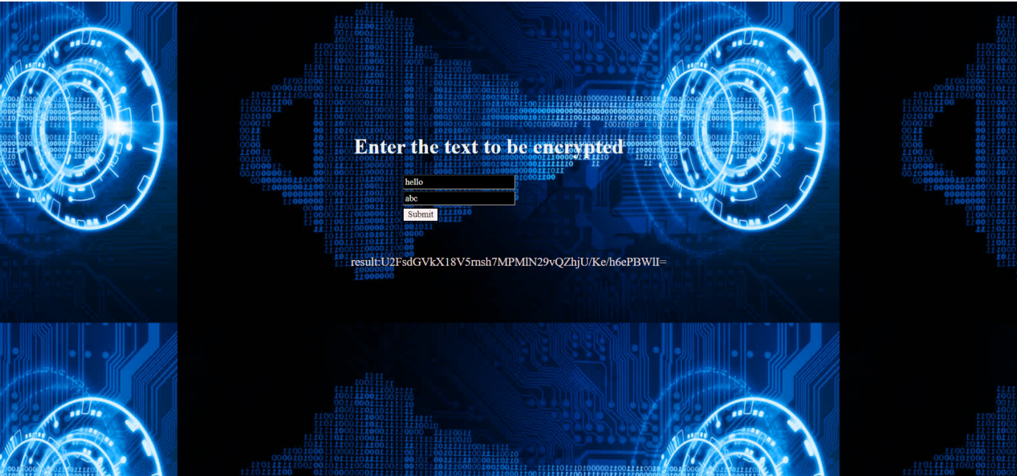

And when the receiver will enter this cipher text in text decryption option along with the private key shared between sender and receiver he will get the corressponding plain text for it.

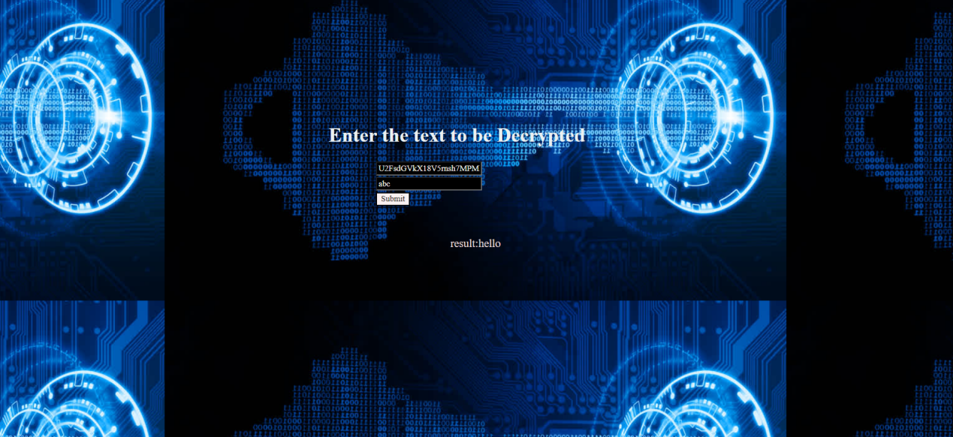

**Algorithm 3: Permutation based image encryption.**

**Libraries Used:**

1. **Pillow**: We have used this for getting the details of image and manipulating it as well
2. **OS** : We have used it for changing and accessing files present in different directories.
3. **Numpy** : We have used it for arranging pieces of image vertically and horizontally.
4. **OpenCv** : We have used it for Reading the image.
5. **Tkinter** : It is used for GUI purpose.
6. **Image Slicer** : We have used it for slicing the image for better encryption.

**Working:**

1. As the first step I used Image.Pillow to accessed the image which i wanted to encrypt.
2. I Printed it's original size for knowing the dimension (height, width) of image.
3. Then I resized the image to such a number that I get a perfect 4x4 grid of image and saved it.
4. Afterwards I accessed the resized image for further processes.
5. I sliced the image using image_slicer to manually given pieces.
6. Then I read every image using OpenCv library and saved them all into a variable.
7. Then stored every image horizontally in different variables [h_stack (1-4)].
8. Then stored every horizontal variable in vertical variables [v_stack (1-2)].
9. At this moment we have resized the original image and sliced it into different parts (all of equal size) and arranged every part in such a way that we get the resized image as it is in the form of a grid.
10. Then added permutation to shuffle every piece to encrypt it.
11. Made a GUI using Tkinter library to access the original image and the permuted image systematically

**CODE:**

from PIL import Image  
import os  
import numpy as np  
import cv2  
  
img = Image.open("D://pic1.jpg", 'r')  
a, b = img.size # a=Width and b=Height  
print("------------------------------")  
print("Old Size:")  
print("Width = ", a, end="\t")  
print("Height = ", b)  
  
print("---------------------------------")  
os.chdir('C:\\Users\\91702\\Desktop\\pic')  
  
size = (800, 800)  
# resize image  
out = img.resize(size)  
# save resized image  
out.save('resized.jpg')  
img1 = Image.open("C:\\Users\\91702\\Desktop\\pic\\resized.jpg", 'r')  
c, d = img1.size # w=Width and h=Height  
print("New Size:")  
print("Width =", c, end="\t")  
print("Height =", d)  
print("------------------------------")  
  
import image_slicer  
  
image_slicer.slice("C:\\Users\\acer\\Desktop\\pic\\resized.jpg", 16)  
print(os.getcwd())  
print("------------------------------")  
  
a = cv2.imread("C:\\Users\\acer\\Desktop\\pic\\resized_01_01.png")  
b = cv2.imread("C:\\Users\\acer\\Desktop\\pic\\resized_01_02.png")  
c = cv2.imread("C:\\Users\\acer\\Desktop\\pic\\resized_01_03.png")  
d = cv2.imread("C:\\Users\\acer\\Desktop\\pic\\resized_01_04.png")  
e = cv2.imread("C:\\Users\\acer\\Desktop\\pic\\resized_02_01.png")  
f = cv2.imread("C:\\Users\\acer\\Desktop\\pic\\resized_02_02.png")  
g = cv2.imread("C:\\Users\\acer\\Desktop\\pic\\resized_02_03.png")  
h = cv2.imread("C:\\Users\\acer\\Desktop\\pic\\resized_02_04.png")  
i = cv2.imread("C:\\Users\\acer\\Desktop\\pic\\resized_03_01.png")  
j = cv2.imread("C:\\Users\\acer\\Desktop\\pic\\resized_03_02.png")  
k = cv2.imread("C:\\Users\\acer\\Desktop\\pic\\resized_03_03.png")  
l = cv2.imread("C:\\Users\\acer\\Desktop\\pic\\resized_03_04.png")  
m = cv2.imread("C:\\Users\\acer\\Desktop\\pic\\resized_04_01.png")  
n = cv2.imread("C:\\Users\\acer\\Desktop\\pic\\resized_04_02.png")  
o = cv2.imread("C:\\Users\\acer\\Desktop\\pic\\resized_04_03.png")  
p = cv2.imread("C:\\Users\\acer\\Desktop\\pic\\resized_04_04.png")  
  
h_stack1 = np.hstack([a, b, c, d])  
h_stack2 = np.hstack([e, f, g, h])  
h_stack3 = np.hstack([i, j, k, l])  
h_stack4 = np.hstack([m, n, o, p])  
  
h_stack5 = np.hstack([d, c, b, a])  
h_stack6 = np.hstack([h, g, f, e])  
h_stack7 = np.hstack([l, k, j, i])  
h_stack8 = np.hstack([p, o, n, m])  
  
v_stack1 = np.vstack([h_stack1, h_stack2, h_stack3, h_stack4])  
v_stack2 = np.vstack([h_stack8, h_stack7, h_stack6, h_stack5])  
  
import tkinter.messagebox  
from tkinter import *  
  
win = Tk() # creating the main window and storing the window object in 'win'  
win.title('Login') # setting title of the window  
win.geometry('500x200') # setting the size of the window  
  
  
def func1(): # function of the button  
 tkinter.messagebox.showinfo(cv2.imshow("Original Image", v_stack1))  
  
  
def func2(): # function of the button  
 tkinter.messagebox.showinfo(cv2.imshow("Applied Permutation", v_stack2))  
 win1 = Tk()  
 win1.title('Reverse Permutation')  
 win1.geometry('500x200')  
  
 def func3(): # function of the button  
 win.destroy()  
 tkinter.messagebox.showinfo(cv2.imshow("Reverse Permutation", v_stack1))  
  
 btn3 = Button(win1, text="Apply Reverse Permutation", width=30, height=2, command=func3)  
 btn3.place(x=140, y=55)  
  
  
btn1 = Button(win, text="Original Image", width=30, height=2, command=func1)  
btn1.place(x=140, y=55)  
  
btn2 = Button(win, text="Apply Permutation On Image", width=30, height=2, command=func2)  
btn2.place(x=140, y=105)  
  
win.mainloop() # running the loop that works as a trigger  
cv2.waitKey(0)  
cv2.destroyAllWindows()

**Screen Shots:**

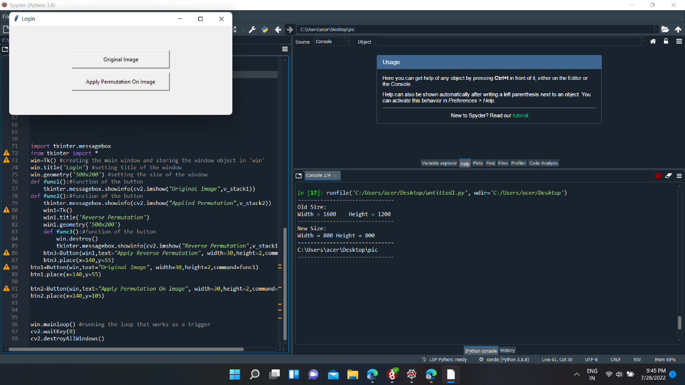

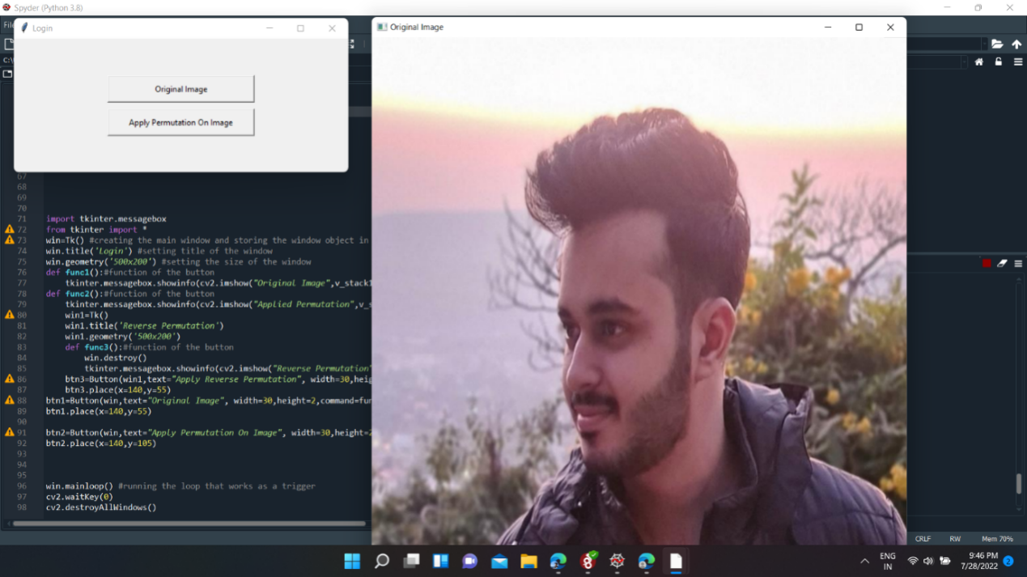

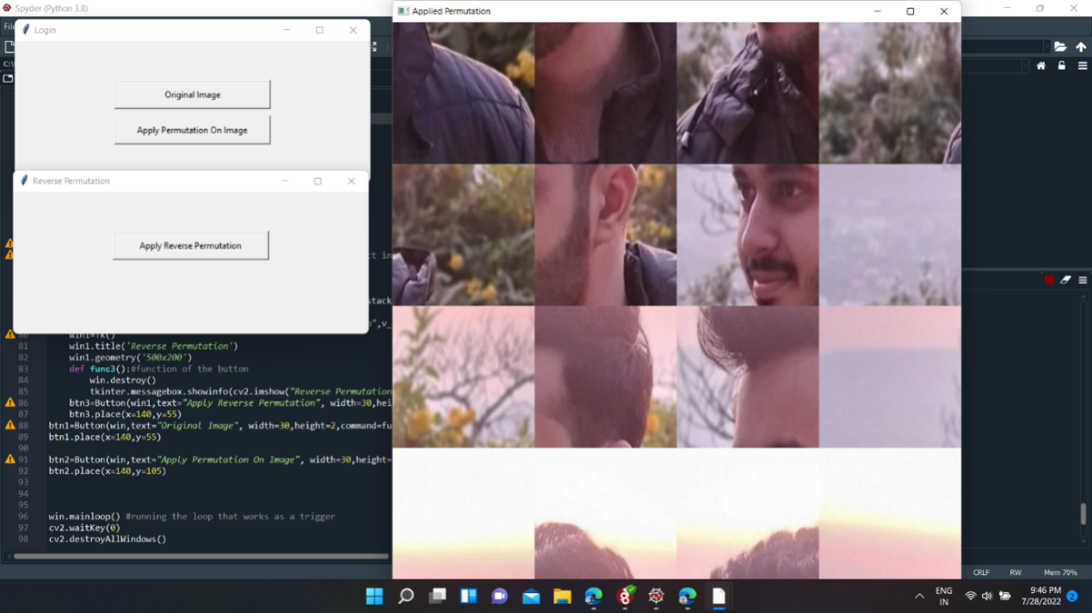

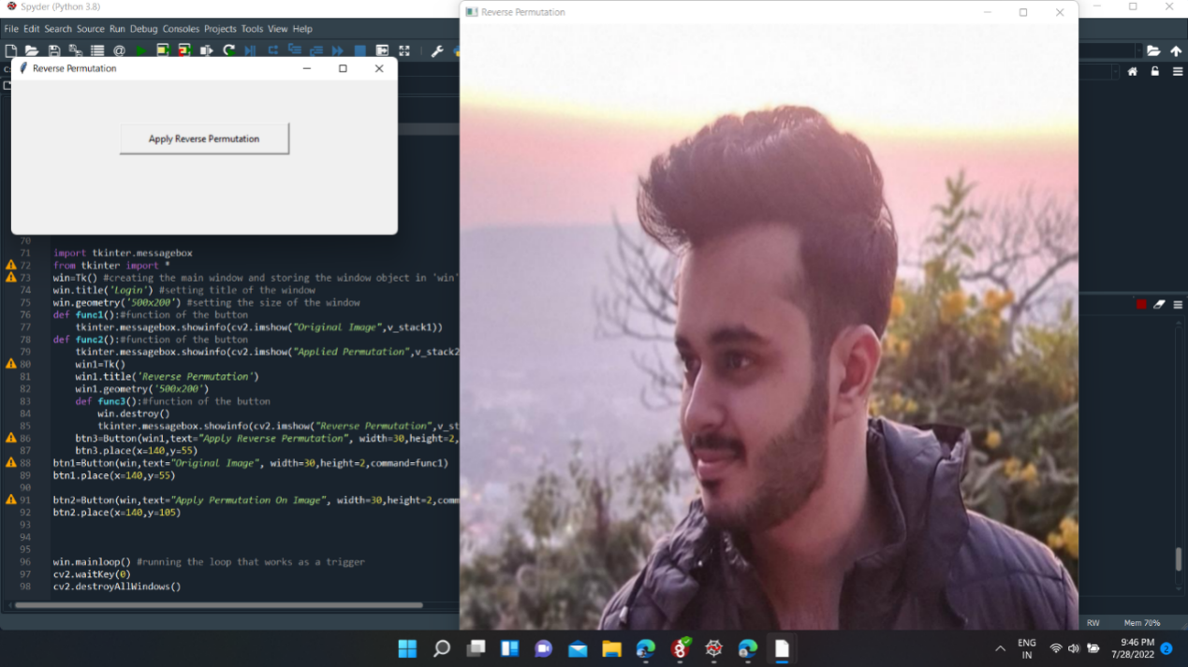

**4 Future Scopes**

* :adding more algorithms for image encryption
* :adding more algorithms for image decryption
* :adding more algorithms for Text encryption
* :adding more algorithms for Text decryption
* :Algorithms used in our project can be used in any social media application to share images and messages in encrypted manner.

**5 References**

* <https://www.geeksforgeeks.org/software-engineering-rapid-application-development-model-rad/>
* <https://www.geeksforgeeks.org/advanced-encryption-standard-aes/>
* <https://developer.mozilla.org/en-US/>
* <https://www.ijcaonline.org/volume28/number8/pxc3874748.pdf>
* [https://www.acadpubl.eu/jsi/2018-118-7-9/articles/8/38.f](https://www.acadpubl.eu/jsi/2018-118-7-9/articles/8/38.pdf)